- Copy and paste the whole folder into the new location, there are hidden documents and folders inside the folder, so make sure you copy the entire folder.
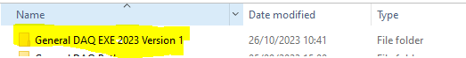
- Install NI-DAQ mx from the following website: https://www.ni.com/en/support/downloads/drivers/download.ni-daq-mx.html#477807
- Install NI-MAX from the following website:
https://www.ni.com/en/support/downloads/drivers/download.system-configuration.html#371210
- Double click General DAQ EXE 2023 Version 1 to enter the folder, and click DAQ_Main.exe
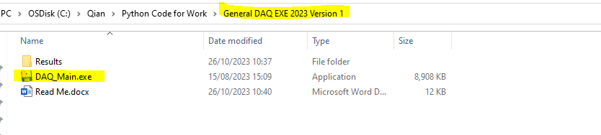
- If you need to define your own file name (“defined name + date & time.csv”), enter it in File Name and press OK. If you don’t define a file name, a default file name “Experiment Result + date & time.csv” will be given.
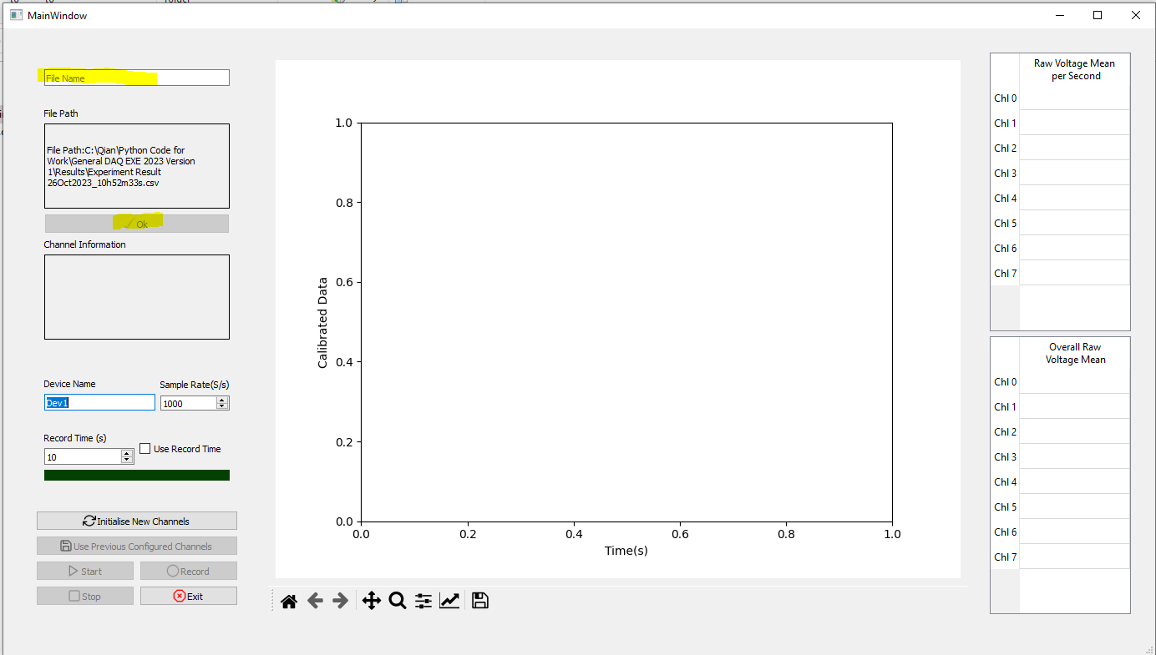

- If your PC connect the NI6009/6003 for the first time, then Device Name would be Dev1. You can always check out Device Name on “NI MAX” software that you installed earlier. Click Devices and Interfaces, the NI device that is connected to your pc will be shown. In this case, the NI6009 is named as ‘Dev1’.
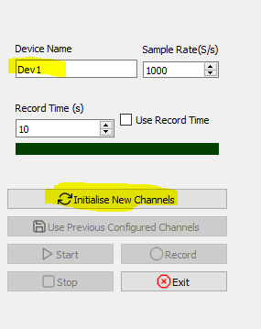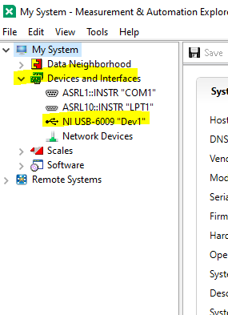
DAQ_Main.exe NI MAX
- Choose the Sample Rate and Select Initialise New Channels, a new window will open. Enter the Channel Name, Scale and Offset. Make sure you tick Select Channel, then click OK.
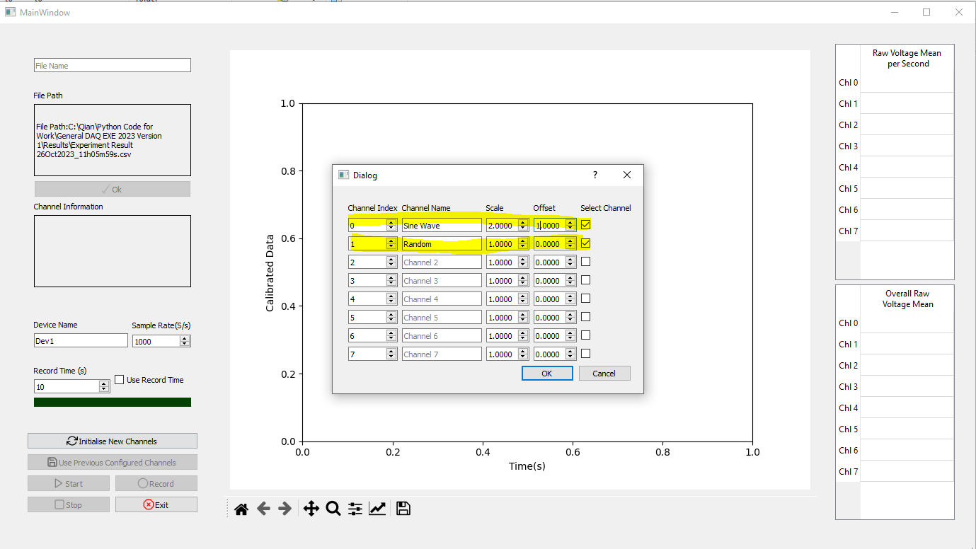

- Click Start to start data acquisition.
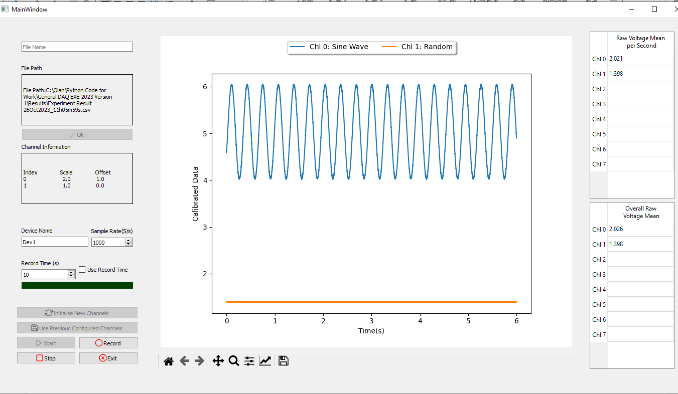
- If you need to record the data at any point, you can click Record. If you like to use the Record Time(s), make sure that Use Record Time box is ticked. Once you click Record, the LED light will be turned on(red). Case A will save data till you press Stop, Case B will save data for 10 second. File will be saved in Results folder as csv file.
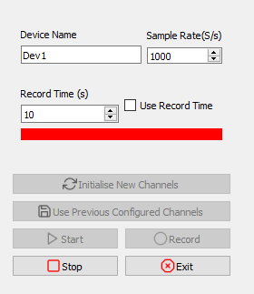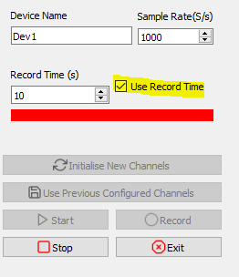
A B
- Once you press Stop, you can start from step 5 again. However, you can skip step 7 if you want to use previous channel setting by clicking Use Previous Configured Channels instead of Initialise New Channels.
